**Task 1:**

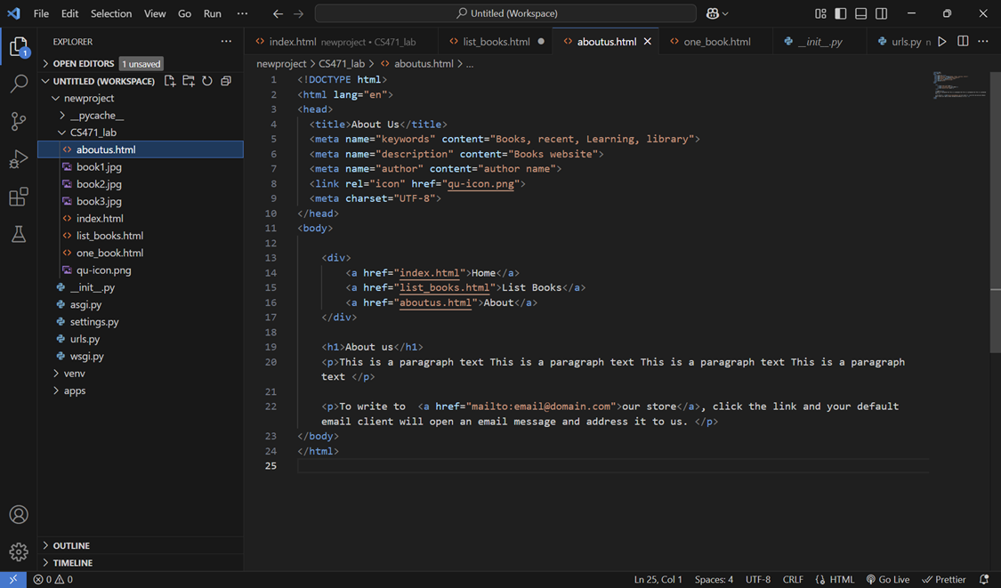

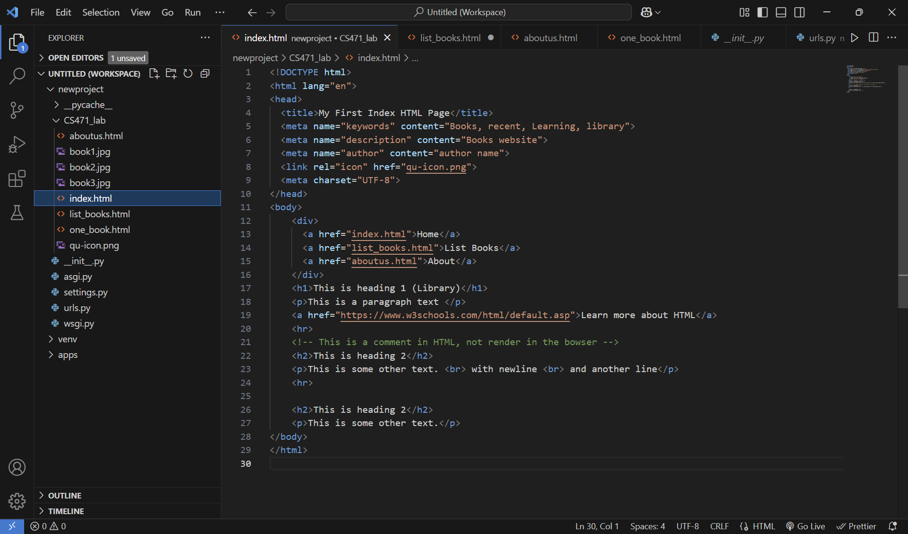

**Task 2:**

**Task 3:**

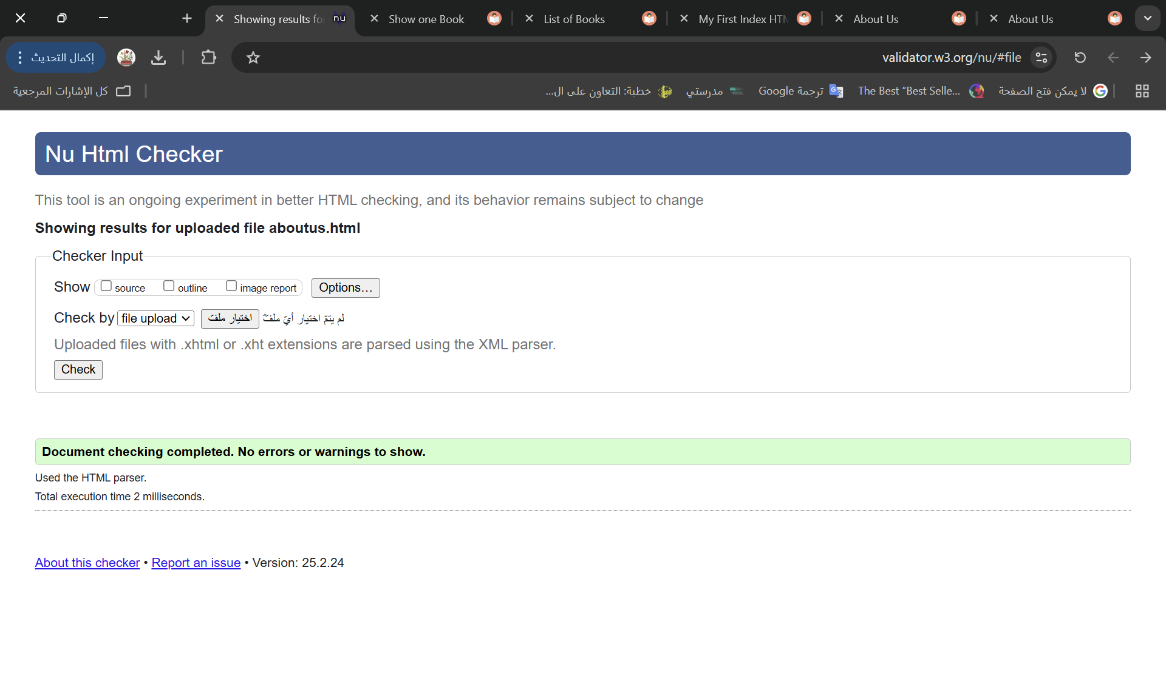

**Task 4:**

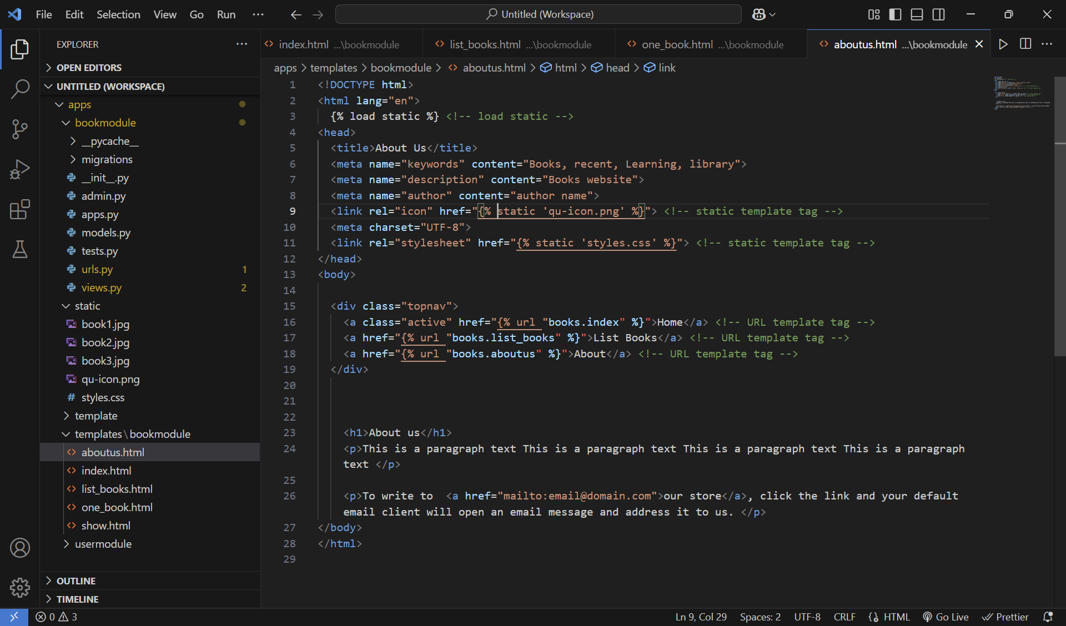

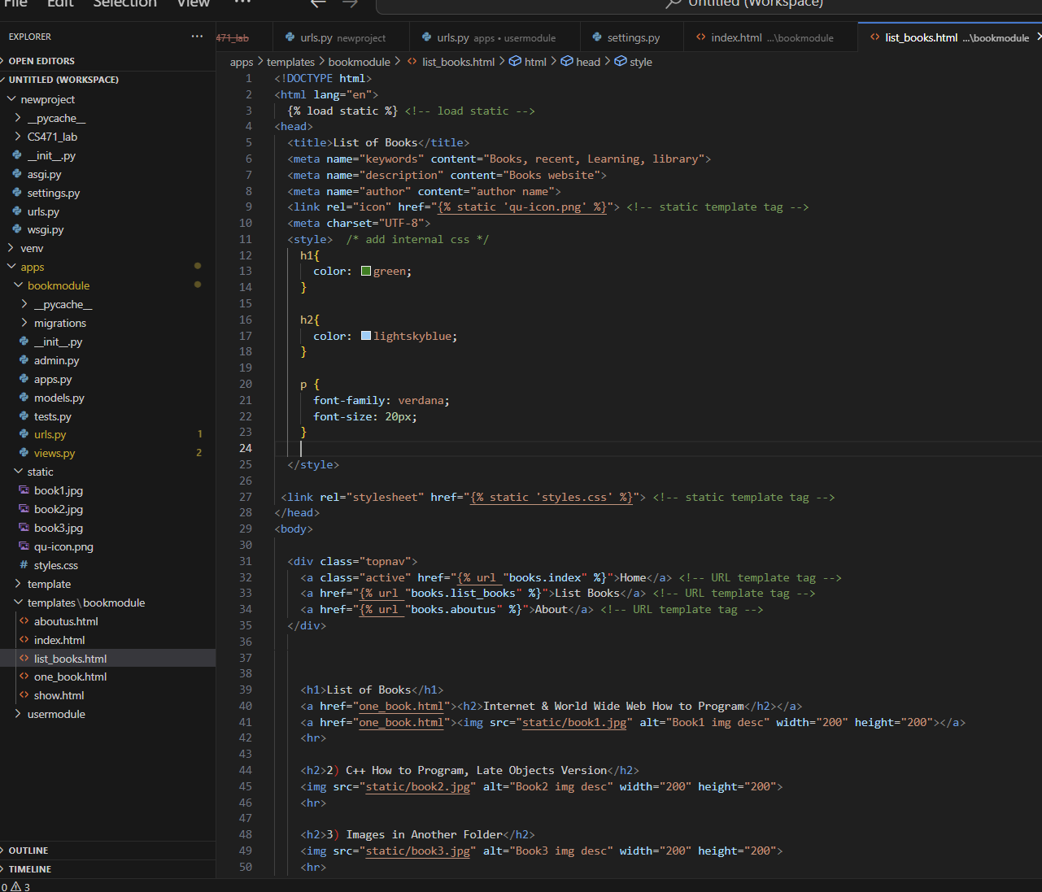

**

**Task 5:**

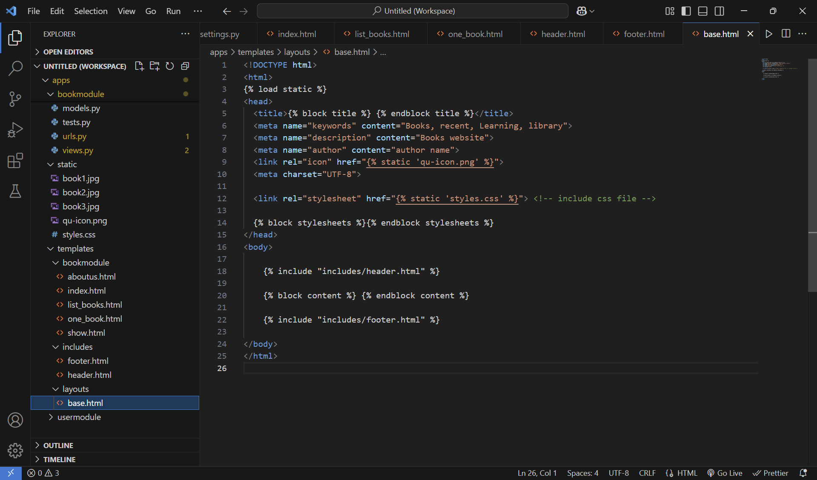

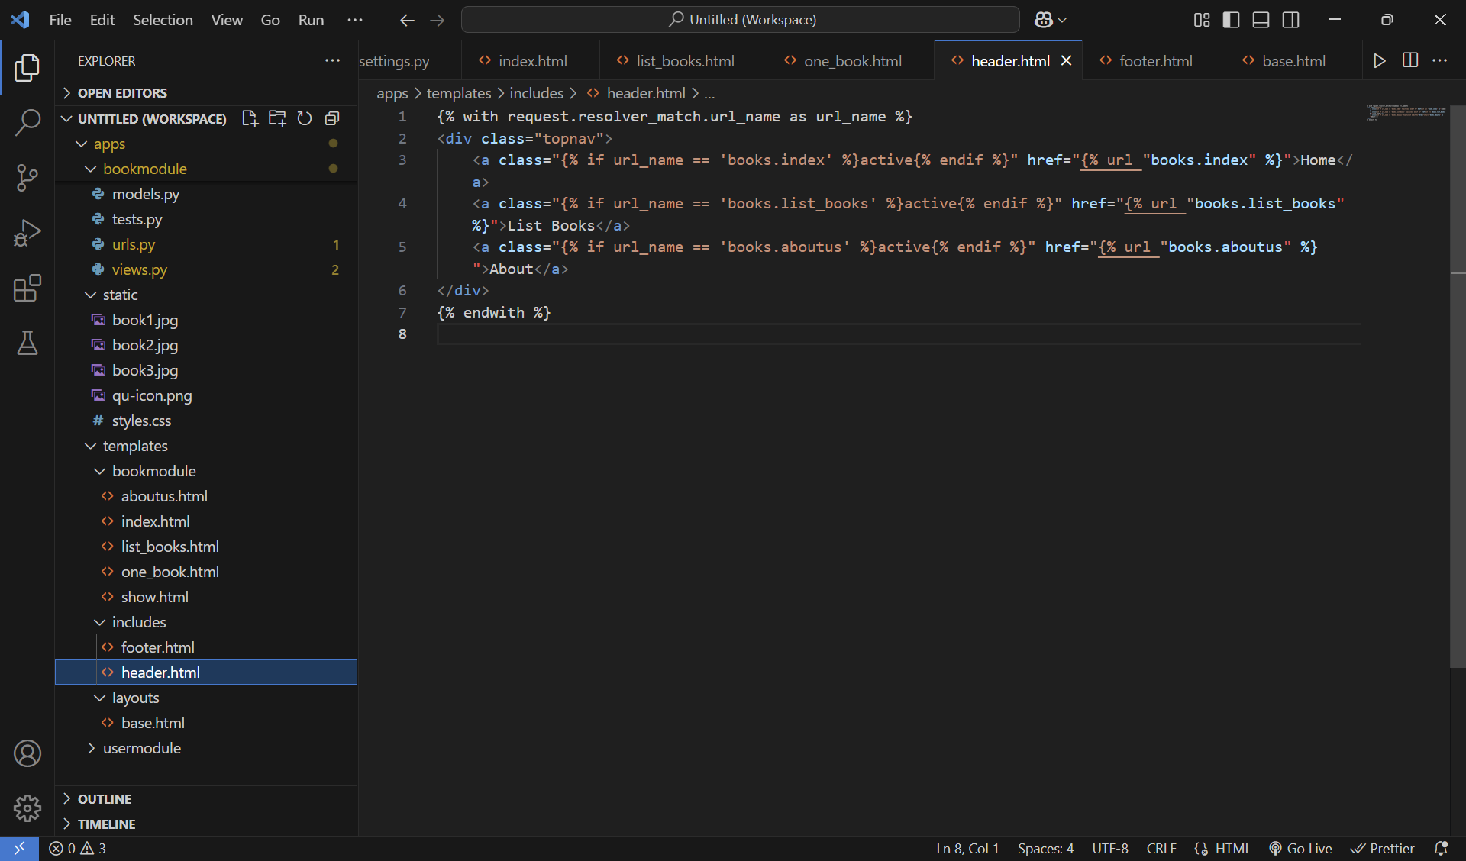

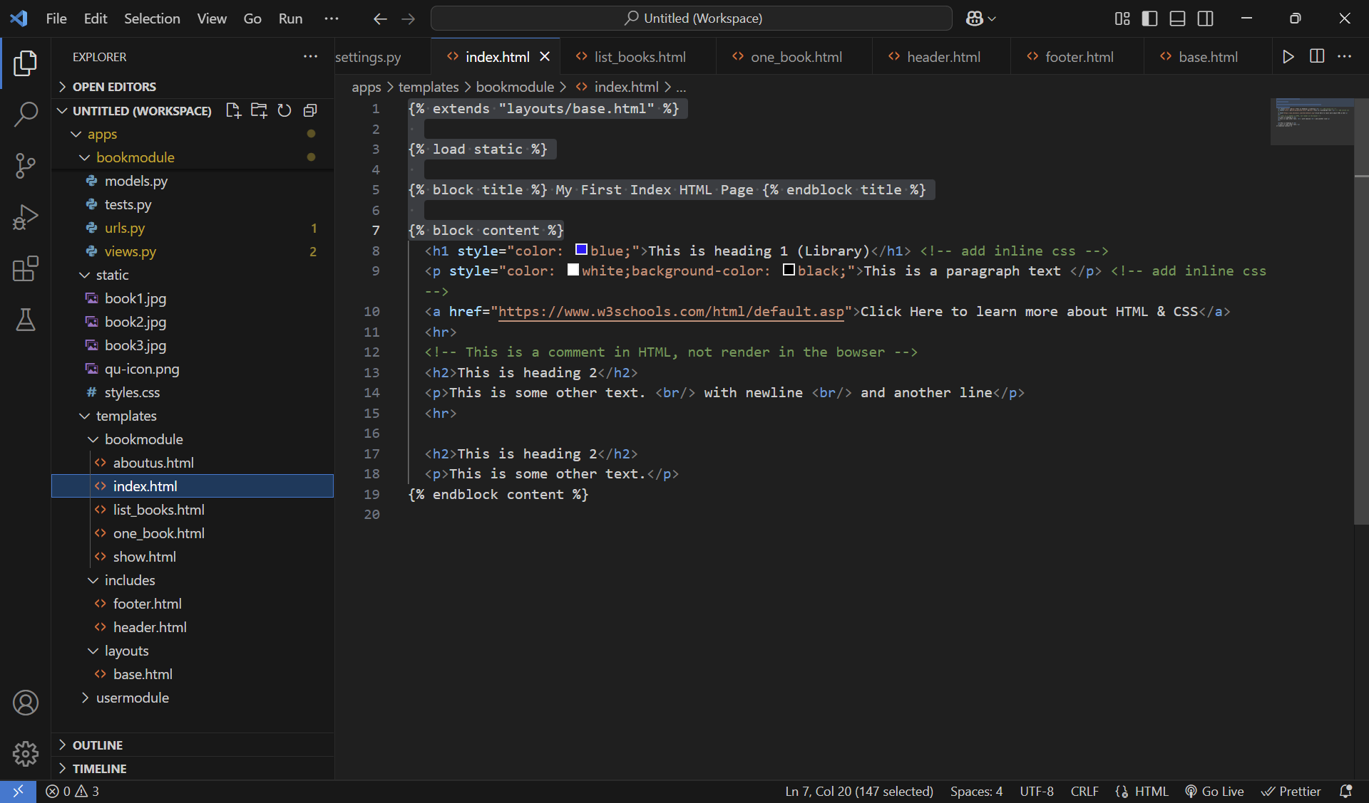

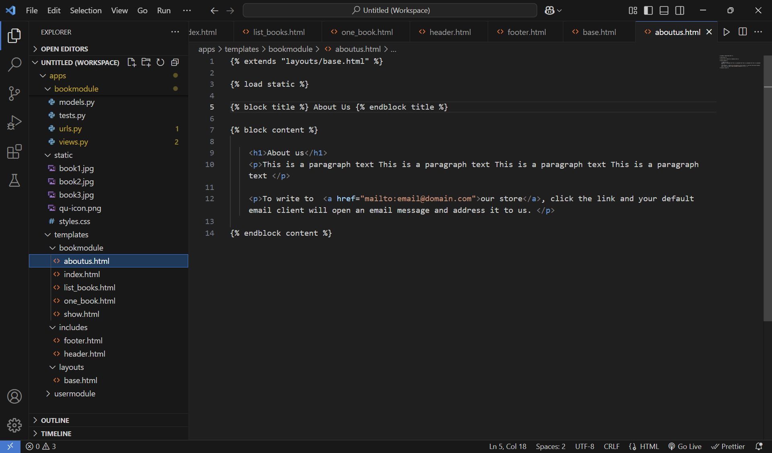

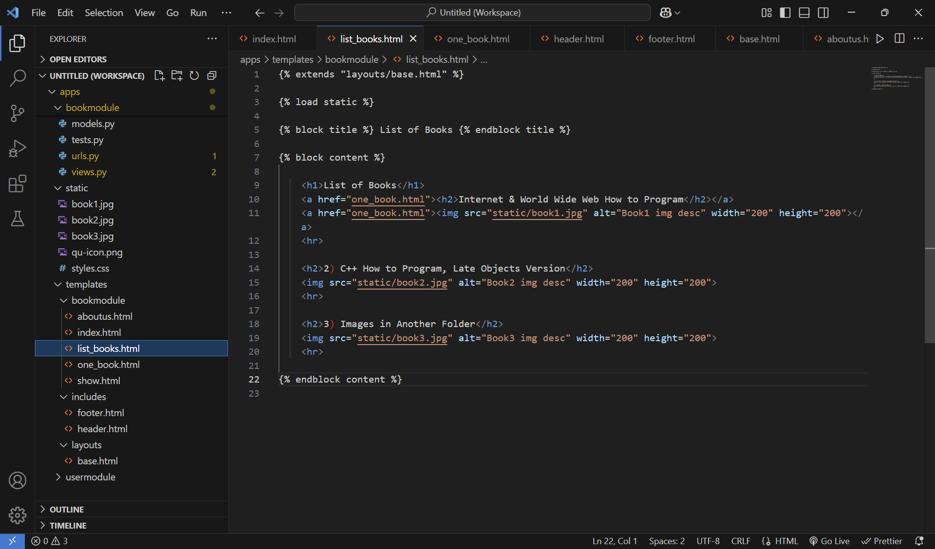

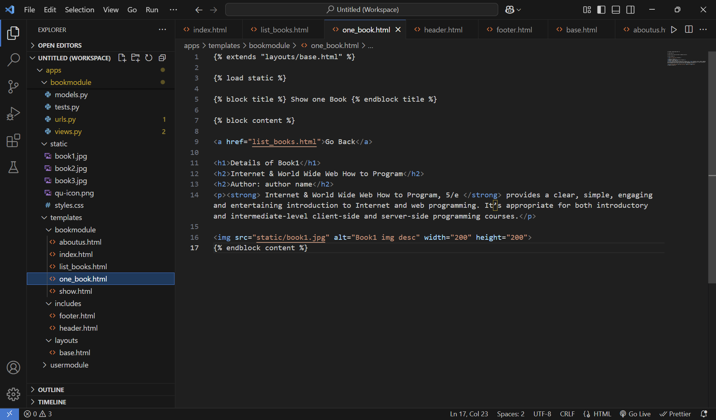

**Step 6:** Now from the browser navigate to <http://127.0.0.1:8000/books/>

